An Explainable Multi-Source Spatiotemporal Machine Learning Approach for Traffic Accident Hotspot Prediction and Severity Classification in Sri Lanka
L.P.N.R.R. Pathirana  School of Computing and Engineering  National Institute of Business Management  Colombo, Sri Lanka  rahalnesara@gmail.com | Niranga Dharmarathne  School of Computing and Engineering  National Institute of Business Management  Colombo, Sri Lanka  niranga@nibm.lk

Abstract—Road traffic accidents (RTA) pose a significant threat to human lives and the economy of Sri Lanka. Even though researchers have incorporated machine learning technologies to reduce the impacts of RTA, most of those implementations still rely on a single data source and consider hotspots as static components. Moreover, these implementations do not explain feature contribution to a prediction. Therefore, this paper presents an explainable, multi-source spatiotemporal machine learning approach for monthly accident hotspot prediction and severity classification, addressing the Sri Lankan context. Unlike many other developed countries, Sri Lanka lacks a proper data management system to handle accident-related data. As a result, accident-related information is still managed via physical handwritten books. Due to these limitations, this study has synthetically generated 3,688 accident records, which were merged with the obtained weather data. Such data were then indexed into H3 hexagonal cells, where hotspot identification using a Poisson test with Benjamini–Hochberg false discovery rate control was implemented, creating a leakage-safe cell-month panel for model training. Logistic Regression, Random Forest, and XGBoost were then trained and evaluated to find the candidate model for each prediction task. Then SHAP was integrated into each candidate model, improving transparency and interpretability of the models. Finally, both prediction and their feature contributions were visualized through a developed prototype dashboard. However, this research is positioned within the Design Science Research Λ contribution, ensuring no claims about real accident patterns. Rather, it should be interpreted as a reusable framework that is rigorously evaluated to demonstrate its feasibility.
Keywords—traffic accident hotspot prediction, severity classification, explainable AI, SHAP, spatiotemporal analysis, synthetic data, Sri Lanka

Introduction
Road traffic accidents kill around 1.19 million people worldwide each year and impose heavy costs on health systems and economies [1]. Sri Lanka follows the same pattern: road deaths rose by 322 in 2025 to 2,710 [2], and the economic cost of fatalities alone has been estimated at about 0.25% of GDP per year, exceeding the government's capital expenditure on health [3]. Existing countermeasures such as new laws, fines and awareness campaigns are largely reactive, and accident numbers continue to fluctuate [4].
Machine learning (ML) offers a proactive alternative by predicting where and when accident risk will rise. However, three gaps limit its use in Sri Lanka. First, local studies rely on police records alone, although contextual data such as weather is known to improve prediction. Second, accident risk varies across locations and over time, yet local work treats hotspots as fixed. Third, ML models act as black boxes, so authorities cannot see why a location is flagged, which limits trust in safety-critical settings. A further practical barrier is data availability: Sri Lanka has no centralised digital accident database, and most station records are handwritten [5].
This study addresses these gaps through Design Science Research (DSR) [6]. Its contributions are:
- a leakage-safe, multi-source cell–month training panel that combines accident and weather data on an H3 hexagonal grid;
- a statistical, month-by-month hotspot definition based on a Poisson test with Benjamini–Hochberg correction;
- a comparison of Logistic Regression (LR), Random Forest (RF) and XGBoost under rolling temporal validation for hotspot prediction and severity classification;
- SHAP explanations integrated into the prediction pipeline and delivered through a REST API and dashboard.
Gregor and Hevner [6] distinguish two kinds of knowledge contribution in DSR. A Λ (lambda) contribution is prescriptive: it shows that a novel artefact can be designed, implemented and rigorously evaluated to address a problem. An Ω (omega) contribution is descriptive: it reports insights about real-world phenomena, which requires evidence from the artefact in use. Because the models here are trained on synthetic data anchored to published sources, this work is a Λ contribution only. All reported metrics demonstrate the framework and its evaluation procedure; none of them is a claim about where, when or how severely road traffic accidents actually occur in the Colombo Municipal Area (CMA).

Related Work
Supervised ML is widely used for accident hotspot and severity prediction. Santos et al. [7] compared Decision Trees, RF, LR and Naïve Bayes in Portugal and found RF performed best, with DBSCAN identifying accident-prone clusters. Islam et al. [8] combined RF, XGBoost and LR with Getis-Ord G_{i}* hotspot analysis in Saudi Arabia, and RF again achieved the highest severity accuracy. Amorim et al. [9] classified hotspots on Brazilian highways and showed that adding weather variables improved performance, while Yan and Shen [10] reported similar gains from contextual features for RF-based severity prediction.
Spatiotemporal modelling has received growing attention. Ogungbire and Pulugurtha [11] combined XGBoost with space-time cube analysis and Getis-Ord G_{i}* to map weather-related crash risk in North Carolina, and Gedamu et al. [12] showed that crash patterns differ across space, time and severity. For interpretability, Al-Omari et al. [13] and Aboulola [14] applied SHAP [15] to severity models, and a recent review recommends explainable AI as a priority for the field [16].
In Sri Lanka, Jayamanna and Kalansooriya [17] developed a mobile application that predicts hotspots and severity from Mount Lavinia police records, with XGBoost and RF performing best, and Nalaka et al. [18] mapped hotspots on the Southern Expressway using GIS interpolation. Both rely on a single data source, and neither models temporal variation or explains predictions. To the best of our knowledge, no Sri Lankan study combines multi-source data, spatiotemporal features and SHAP-based explanations in one approach.

Methodology

Research Design and Data Sources
The study follows the DSR process of problem identification, solution design, development and evaluation [6], under a pragmatist philosophy. Three data sources were used. First, 44 anonymised accident records for 2022 were transcribed by hand from the Slave Island Police Station books, with ethical approval; they defined the record structure but were too few for training. Second, 3,688 synthetic records for 2022–2023 were generated for 17 of the 22 Colombo police divisions, covering about 95% of reported accident volume. Each attribute was anchored to a published source (Table I): divisional counts to Department of Census and Statistics tables [19], the severity mix to national police statistics [20], time-of-day and cause distributions to fatal [21] and non-fatal [22] accident studies, and street names to OpenStreetMap via OSMnx [23]. Because independent sampling cannot create relationships between attributes, three conditional rules shift severity one level upward with a combined probability capped at 50%: R1, night-time on a main road (+10%); R2, motorcycle or pedestrian involvement (+15%); and R3, alcohol as the cause (+20%). A fixed random seed makes the dataset reproducible. Third, daily Colombo weather for the same period was obtained from the Visual Crossing API [24] and aggregated to monthly features.
- Empirical Sources Used to Anchor the Synthetic Data
ID | Source | Attribute anchored
A1 | Department of Census and Statistics [19] | Accidents per police division, 2022–2023
A2 | Sri Lanka Police traffic reports [20] | National severity mix
A3 | Thilakarathna et al. [21] | Time and cause, fatal accidents
A4 | Jayasinghe et al. [22] | Time and cause, non-fatal accidents
A5 | OpenStreetMap via OSMnx [23] | Street names per division

Not all anchors are Colombo-specific: the severity mix is national, and the time and cause distributions come from studies in Ragama and Matara. This is accepted within the Λ scope, as the aim is to test the method with Sri Lankan-sourced distributions rather than to reproduce Colombo accident patterns exactly.

Spatial Indexing and Hotspot Labelling
Accident locations were geocoded with the Google Maps API and indexed into Uber's H3 hexagonal grid [25]. Hexagons give each cell six equidistant edge neighbours, avoiding the corner-adjacency problem of square grids. Resolution 8 (about 0.737 km² per cell) was chosen over resolution 9 to avoid sparse cells, giving 79 cells and a panel of 1,896 cell–months (79 cells × 24 months).
Hotspots are defined for each cell and each month. For target month T, the expected count under complete spatial randomness is the mean count across all cells, including cells with no accidents:
λ_{T} = (1/|C|) Σ_{c∈C} n_{c,T} (1)
where C is the set of 79 cells and n_{c,T} is the number of accidents in cell c during month T. Each cell's one-sided p-value is
p_{c,T} = P(X ≥ n_{c,T}), X ~ Poisson(λ_{T}) (2)
To control false positives across the 79 tests of each month, the Benjamini–Hochberg procedure [26] is applied within the month: with p-values ranked in ascending order, the k-th is significant if
p_{(k)} ≤ kα/m (3)
with m = 79 and α = 0.05. A cell is labelled a hotspot for month T when its adjusted p-value is below 0.05, that is, when its count is significantly higher than the citywide monthly average. Unlike a fixed percentile threshold, this gives every label a statistical basis. The procedure produced 108 hotspot cell–months (5.7%).

Leakage-Safe Spatiotemporal Features
Every feature for row (c, T) uses only information available before the first day of the month, s_{T}. Rolling accident counts for the same cell and for its six first-order neighbours N(c) are computed for windows w of 30, 90 and 180 days:
S_{c,T}(w) = |{ j : c_{j} = c, s_{T} − w ≤ t_{j} < s_{T} }| (4)
where t_{j} is the date of accident j; the neighbour count replaces c_{j} = c with c_{j} ∈ N(c). The panel also includes 180-day shares of peak-hour, night-time and motorcycle accidents, the previous month's weather (precipitation, humidity, visibility, cloud cover and share of rainy days), calendar terms, cell coordinates and police division, giving 36 features. For severity, each cell–month with at least one accident is labelled with its dominant severity class (Fatal, Serious, Minor or Damage-only), giving 1,112 rows.

Model Training and Evaluation
LR, RF and XGBoost were trained for both tasks with class-imbalance handling (balanced class weights for LR and RF; positive-class weighting or balanced sample weights for XGBoost). Data up to August 2023 were used for training, and September–December 2023 were held out as an untouched test window (316 hotspot rows, 15 positives; 195 severity rows). Within the training period, rolling temporal validation with six two-month folds was used to select the model, tune the hotspot decision threshold and set the number of XGBoost rounds; preprocessing was fitted on training folds only. The hotspot winner was chosen by pooled validation F1 and the severity winner by mean validation macro-F1. The synthetic data were evaluated separately with chi-square goodness-of-fit tests against each anchor (α = 0.05) and chi-square independence tests for rules R1–R3. Table II summarises the model configurations.
- Model Configurations
Model | Main settings (both tasks unless stated)
LR | Standardised features; balanced class weights; liblinear solver (hotspot), lbfgs (severity)
RF | 300 trees; maximum depth 8; minimum 5 samples per leaf; √p features per split; balanced class weights
XGBoost | Learning rate 0.05; maximum depth 5; subsample 0.8; positive-class weight (hotspot) or balanced sample weights (severity); rounds set from rolling validation

Evaluation Strategy and Scope of Claims
Evaluation followed an ex post strategy within the FEDS framework [27], carried out in a controlled, benchmark-style setting rather than with live data or real users. It has two layers. Synthetic data validation checks that the generated records reproduce their published anchors and that the conditional rules behave as designed. Framework validation checks that each component works and performs as specified: model metrics on the temporal test window, seven scripted functional test cases derived from the functional requirements, response times measured over 20 sequential requests per API endpoint, and a heuristic usability review of the dashboard based on a reduced set of Nielsen's heuristics plus an explanation-specific check. Neither layer establishes ground truth about road traffic accidents. A high score shows that the pipeline can learn and explain the structure present in its training data; it does not show that the same structure exists in real CMA accidents.

Explainability and Delivery
SHAP TreeExplainer [15] was integrated with the selected models to produce global feature rankings and the four strongest contributions for every prediction. The system follows the five-layer architecture in Fig. 1: data sources; ETL and feature engineering; storage in MongoDB Atlas; modelling and explainability; and delivery through seven FastAPI endpoints to a React Leaflet dashboard with month and police-division filters.
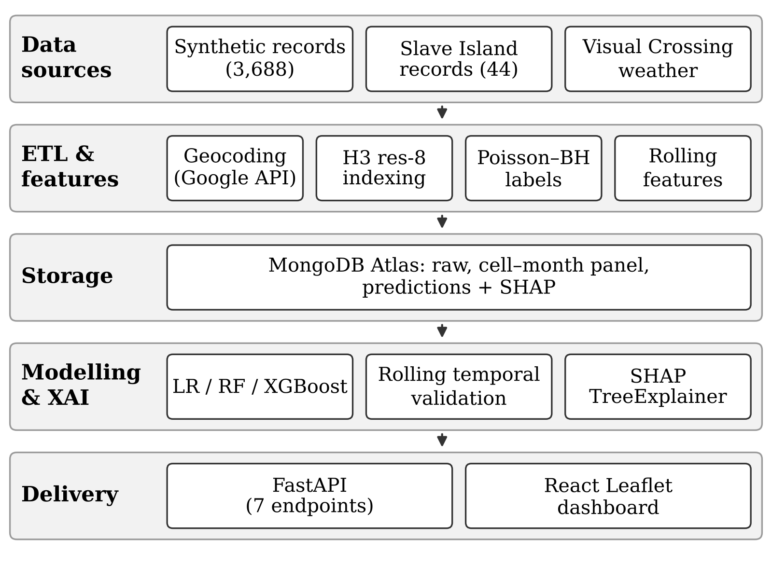
- Five-layer architecture of the proposed approach.

Results
In line with the Λ scope, the results below describe how the framework behaves on source-anchored synthetic data. Cells, months and hotspots refer to the synthetic panel, not to observed accidents in Colombo.

Synthetic Data Fidelity
Eight of the nine tested attributes showed no significant difference from their anchors (Table III). The only divergence, severity after rules R1–R3, is intended, since the rules deliberately raise severity; severity before the rules matched its source (p = 0.270). Independence tests confirmed that all three rule effects were significant (p < 0.001). These results show fidelity to the published sources, not to real Colombo accidents.
- Chi-Square Goodness-of-Fit of the Synthetic Data
Attribute (anchor) | χ² (df) | p-value
Severity, before rules (A2) | 3.93 (3) | 0.270
Severity, after rules (A2) | 97.71 (3) | < 0.001*
Severity, Slave Island (A2) | 7.67 (3) | 0.053
Time of day, fatal (A3) | 4.47 (3) | 0.215
Time of day, non-fatal (A4) | 3.67 (4) | 0.453
Cause, fatal (A3) | 11.18 (8) | 0.192
Cause, non-fatal (A4) | 5.03 (8) | 0.755
Collision type (A3) | 2.33 (3) | 0.507
Driver age group (A3) | 9.14 (6) | 0.166
*Intended divergence caused by conditional rules R1–R3.

Hotspot Prediction
RF was selected with the highest pooled validation F1 (0.495). On the test window it achieved the highest ROC-AUC (0.957) and recall (0.933), identifying 14 of the 15 labelled hotspots with 28 false positives (Table IV). LR obtained a higher test F1 (0.522), but the winner was fixed on validation results to avoid selecting on the test set. The moderate F1 values reflect class rarity: hotspots form only 4.7% of test rows. Because both the labels and the features are derived from the same synthetic records, these figures confirm that the labelling, feature and validation design works end to end, not that Colombo hotspots can be predicted with this accuracy.
- Hotspot Prediction on the Temporal Test Window
Metric | LR | RF* | XGBoost
Validation F1 (pooled) | 0.370 | 0.495 | 0.481
Test F1 | 0.522 | 0.491 | 0.429
Test ROC-AUC | 0.940 | 0.957 | 0.946
Test average precision | 0.478 | 0.478 | 0.382
Test precision | 0.387 | 0.333 | 0.293
Test recall | 0.800 | 0.933 | 0.800
Decision threshold | 0.83 | 0.62 | 0.23
*Selected model. Test window: September–December 2023, 316 cell–months, 15 hotspots.
Fig. 2 shows the ROC and precision–recall curves of the three models. All three rank cell–months well above the random baseline and their ROC curves lie close together. The precision–recall curves are more informative under class imbalance: LR and RF reach an average precision of 0.478, about ten times the base rate of 0.047, while XGBoost reaches 0.382. For the selected RF model, the 316 test rows give 14 true positives, 1 false negative, 28 false positives and 273 true negatives.

Severity Classification
Severity proved much harder (Table V). XGBoost was selected with a validation macro-F1 of 0.258, but its test macro-F1 of 0.236 is close to the 0.25 expected from random guessing across four classes, and its accuracy (0.328) is below the 0.364 obtained by always predicting the majority class, Minor. Fatal and Damage-only accidents were rarely identified. As with the hotspot task, this is a property of the framework on synthetic data, and it is reported to show the evaluation procedure exposing a weak component rather than hiding it.
- Severity Classification on the Temporal Test Window
Metric | LR | RF | XGBoost*
Validation macro-F1 | 0.193 | 0.232 | 0.258
Test macro-F1 | 0.195 | 0.185 | 0.236
Test accuracy | 0.272 | 0.236 | 0.328
F1, Fatal | 0.107 | 0.063 | 0.063
F1, Serious | 0.051 | 0.231 | 0.362
F1, Minor | 0.457 | 0.362 | 0.444
F1, Damage-only | 0.163 | 0.085 | 0.074
*Selected model. Test window: 195 cell–months with at least one accident.
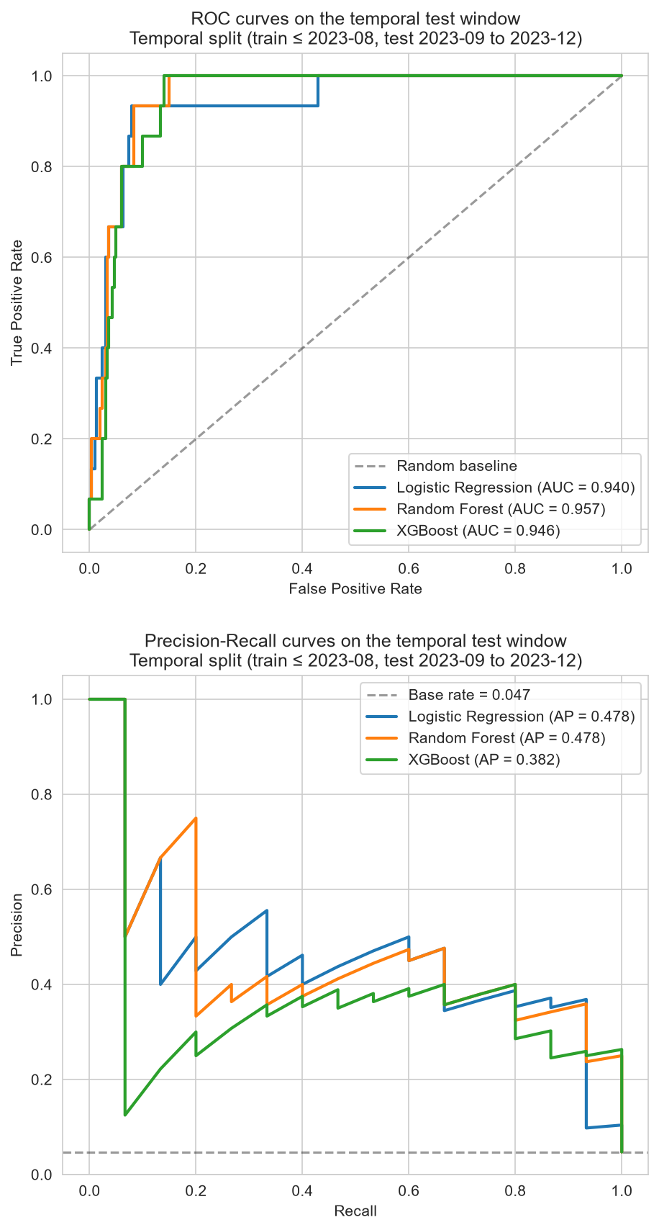
- ROC (top) and precision–recall (bottom) curves of the hotspot classifiers on the temporal test window.

Explainability and System Evaluation
Fig. 3 shows the SHAP summary for the RF hotspot model on the test window. Accident counts in the same cell over the previous 180, 90 and 30 days had the largest impact, followed by cell location and neighbouring-cell counts; temporal shares and month had smaller effects, and weather features contributed least. These rankings explain the model, not real accident causation.
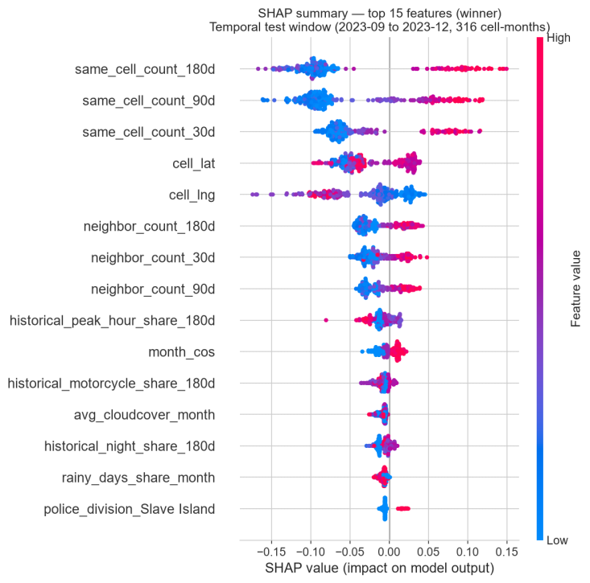
- SHAP summary of the Random Forest hotspot model on the test window (September–December 2023).
Fig. 4 shows the dashboard for November 2023. Each H3 cell is coloured by its predicted hotspot status and dominant severity, and selecting a cell opens its hotspot probability, the observed outcome for that month and the four SHAP contributions behind the prediction. Here, the Slave Island cell is predicted as a hotspot with a probability of 0.90, driven mainly by its accident counts over the previous 180, 90 and 30 days; because the observed outcome is also shown, the user can see that this particular prediction was a false alarm.
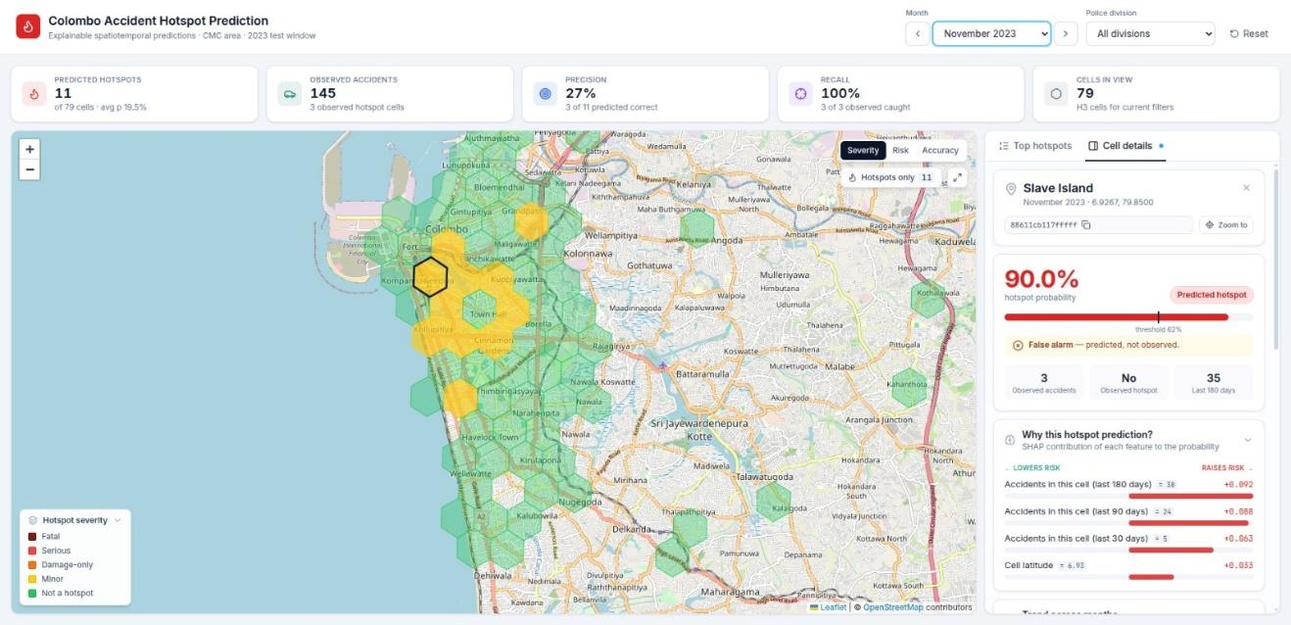
- Dashboard view for November 2023, showing predicted hotspots and the SHAP explanation for a selected cell.
- Response Times of the Deployed Prototype
Request | Mean (ms) | 95th pct. (ms)
GET /cells (all 79 cells) | 717 | 784
GET /cells/{h3_cell} | 498 | 514
GET /hotspots | 711 | 760
GET /severity/{h3_cell} | 506 | 548
GET /xai/{h3_cell} | 503 | 550
Dashboard load, repeat visit | 1,758 | 1,824
Dashboard load, first visit | 2,815 | –
20 sequential requests per endpoint; all requests filtered by month.
All seven functional test cases passed, covering the ETL pipeline, synthetic data generation, panel construction, hotspot labelling, model training, SHAP generation and delivery through the REST API and dashboard. Table VI reports response times for the prototype deployed on Vercel with MongoDB Atlas; they describe a proof of concept, not production performance. In the heuristic review, three heuristics passed (visibility of system status, user control and freedom, and the added check that SHAP direction matches the contribution sign) and four were partially met, mainly because raw SHAP values and the decision threshold are still shown in technical form and the SHAP colour scheme is not fully consistent.

Discussion

Interpretation of Results
The results show that the approach can be built end to end and evaluated rigorously. For hotspots, the high ROC-AUC and recall indicate that the model ranks risky cells well, which suits the operational task of prioritising patrols each month, even though rare positives keep F1 moderate. The month-by-month Poisson labels and pre-cutoff features prevent a model from scoring well by memorising which cells were historically dangerous, so the temporal test measures genuine future prediction.
The weak severity result is itself informative. The features describe accident volume and exposure rather than road type, junction layout, lighting or speed limits, which largely determine severity, and the severity rules in the synthetic data are not linked to location. Severity prediction therefore needs infrastructure data rather than more complex models. Similarly, the small weather effect should not be read as evidence that weather is unimportant: weather was joined after the synthetic records were generated, so no weather–accident relationship existed to be learned.

Comparison with Existing Studies
Table VII compares the approach with the studies reviewed in Section II. Each earlier study covers some of these features, but none combines a Sri Lankan context, multi-source data, spatiotemporal features, SHAP for both tasks and leakage-safe validation in one framework. The contribution is therefore one of integration and rigour of evaluation, rather than of predictive accuracy on real data.
- Comparison with Existing Studies
Feature | [7] | [8] | [9] | [17] | [13] | [11] | Ours
Sri Lankan context | × | × | × | ✓ | × | × | ✓
Weather data | × | × | ✓ | × | × | ✓ | ✓
Spatiotemporal features | ~ | ~ | × | × | × | ✓ | ✓
SHAP explanations | × | × | × | × | ~ | × | ✓
Hotspot and severity | × | ✓ | × | ✓ | × | × | ✓
Leakage-safe validation | × | × | × | × | × | × | ✓
Synthetic data checks | × | × | × | × | × | × | ✓
Dashboard or API | × | × | × | ✓ | × | × | ✓
✓ = present; ~ = partial; × = absent. [13] applies SHAP to severity only; [17] is a mobile application without explanations.

Threats to Validity
Construct validity was supported by taking the severity classes directly from the Sri Lanka Police classification [20] and divisional distributions from census tables [19]; attributes without an empirical source were modelled explicitly and documented. Internal validity faces two main threats. The models are trained and tested on data from the same generator, so they may partly recover the generator's own assumptions; and rules R1–R3 create relationships by design, so the effects the models learn from them must not be read as discovered patterns. Both threats are the reason the results are interpreted as Λ evidence only.
External validity is limited by the 2022–2023 period covered by the anchors, by anchors drawn from outside the CMA, and by the Sri Lankan context of all sources: the method can be transferred, but its results are not generalised. For conclusion validity, fidelity was assessed with explicit significance tests, rule effects were reported as absolute and relative changes in severity, and the 44 real records were treated only as supporting evidence. Reliability is supported by a fixed random seed, documented anchors and rules, and a scripted pipeline that regenerates every result.

Reusable Design Knowledge and Implications
As a Λ contribution, the main reusable outcome is a set of design choices that can be carried over to real data:
- define hotspots per period with a statistical test against a citywide expectation and false discovery rate control, rather than with a fixed count or percentile threshold;
- compute every feature strictly from data before the prediction period, so that evaluation measures genuine forecasting;
- select models, thresholds and boosting rounds on rolling validation and keep the final window untouched;
- anchor every synthetic attribute to a documented source and test its fidelity before any modelling;
- deliver explanations with each prediction and show the observed outcome where available, so users can judge when a prediction is unreliable.
For practice, the framework illustrates how hotspot prediction could support traffic police once it is retrained on real records: a ranked list of cells for the coming month, with the reasons for each, can guide patrol and enforcement planning, while the high recall means few real hotspots are missed at the cost of some false alarms. Realising this depends on digitised, geocoded accident records, which is the most important step for authorities wishing to adopt such methods.
The main limitations follow from data scarcity. Models were trained on synthetic data whose anchors are partly national or from other districts; only 44 real records were available, too few for a strong train-on-synthetic, test-on-real evaluation; the study covers one municipal area; and the dashboard was not evaluated with police users.

Conclusion
This paper presented an explainable, multi-source spatiotemporal approach for monthly accident hotspot prediction and severity classification in Sri Lanka, addressing the reliance on single data sources, the lack of spatiotemporal modelling and the absence of explainability in local work. Using source-anchored synthetic data, statistically defined monthly hotspots and leakage-safe features, RF ranked hotspot cells with a ROC-AUC of 0.957, while severity remained close to chance, and SHAP explanations were delivered for every prediction. Consistent with its Λ positioning, the paper contributes a reusable, rigorously evaluated methodology; its numerical results make no claims about road traffic accidents in the CMA, and real-world (Ω) value can only be established by applying the framework to official records. Future work should retrain the pipeline on digitised police records with a full train-on-synthetic, test-on-real evaluation, add road infrastructure features, extend coverage beyond Colombo, and present SHAP output as plain-language guidance for traffic authorities.

Acknowledgment
The authors thank the Traffic Division of Slave Island Police Station for access to accident records.

References
- World Health Organization, Global Status Report on Road Safety 2023. Geneva, Switzerland: WHO, 2023.
- Daily Mirror, “Road accident deaths rise in 2025,” dailymirror.lk, 2026. [Online]. Available: https://www.dailymirror.lk/breaking-news/Road-accident-deaths-rise-in-2025/108-329246
- T. L. Gunaruwan and P. C. J. Nayanalochana, “Economic cost of human fatalities due to road traffic accidents in Sri Lanka: An estimation based on the human capital approach,” J. South Asian Logist. Transp., vol. 3, no. 1, pp. 39–57, 2023, doi: 10.4038/jsalt.v3i1.59.
- T. L. S. S. Siritunga, “Road traffic crashes in Sri Lanka: An epidemic that demands multisectoral public-health mobilization,” J. Coll. Community Physicians Sri Lanka, vol. 31, no. 4, pp. 116–121, 2025, doi: 10.4038/jccpsl.v31i4.8902.
- N. C. Selvaratnam, N. D. Selvaratnam, P. Lanter, S. D. Dharmaratne, and P. C. Acker, “Evaluating Sri Lanka’s road traffic crash and injury research: A systematic review focusing on data sources and methodological approaches,” Eur. J. Public Health Stud., vol. 8, no. 2, 2025, doi: 10.46827/ejphs.v8i2.214.
- S. Gregor and A. R. Hevner, “Positioning and presenting design science research for maximum impact,” MIS Q., vol. 37, no. 2, pp. 337–355, 2013, doi: 10.25300/MISQ/2013/37.2.01.
- D. Santos, J. Saias, P. Quaresma, and V. B. Nogueira, “Machine learning approaches to traffic accident analysis and hotspot prediction,” Computers, vol. 10, no. 12, p. 157, 2021, doi: 10.3390/computers10120157.
- Md. K. Islam, I. Reza, U. Gazder, R. Akter, M. Arifuzzaman, and M. M. Rahman, “Predicting road crash severity using classifier models and crash hotspots,” Appl. Sci., vol. 12, no. 22, p. 11354, 2022, doi: 10.3390/app122211354.
- B. de S. P. Amorim, A. A. Firmino, C. de S. Baptista, G. Braz Júnior, A. C. de Paiva, and F. E. de Almeida Júnior, “A machine learning approach for classifying road accident hotspots,” ISPRS Int. J. Geo-Inf., vol. 12, no. 6, p. 227, 2023, doi: 10.3390/ijgi12060227.
- M. Yan and Y. Shen, “Traffic accident severity prediction based on random forest,” Sustainability, vol. 14, no. 3, p. 1729, 2022, doi: 10.3390/su14031729.
- A. Ogungbire and S. S. Pulugurtha, “Spatiotemporal risk mapping of statewide weather-related traffic crashes: A machine learning approach,” Mach. Learn. Appl., p. 100642, 2025, doi: 10.1016/j.mlwa.2025.100642.
- W. T. Gedamu, U. P. Wiedenbeck, and B. T. Wodajo, “Spatio-temporal analysis of road traffic crashes by severity,” Transp. Eng., vol. 20, p. 100327, 2025, doi: 10.1016/j.treng.2025.100327.
- A. Al-Omari, M. Alsaleh, and N. Shatnawi, “Spatial-temporal analysis and severity prediction of traffic accidents,” Eng. Sci., 2025, doi: 10.30919/es1472.
- O. I. Aboulola, “Improving traffic accident severity prediction using MobileNet transfer learning model and SHAP XAI technique,” PLoS ONE, vol. 19, no. 4, p. e0300640, 2024, doi: 10.1371/journal.pone.0300640.
- S. M. Lundberg and S.-I. Lee, “A unified approach to interpreting model predictions,” in Proc. Adv. Neural Inf. Process. Syst. (NeurIPS), 2017, pp. 4765–4774.
- N. Hamdan and T. Sipos, “Advancements in machine learning for traffic accident severity prediction: A comprehensive review,” Period. Polytech. Transp. Eng., vol. 53, no. 3, pp. 347–355, 2025, doi: 10.3311/pptr.40369.
- J. M. C. T. Jayamanna and P. Kalansooriya, “Development of an intelligent road safety mobile navigation application using machine learning for real-time accident hotspot and severity prediction: A case study in Sri Lanka,” in Proc. 5th Int. Conf. Adv. Highway Eng. Transp. Syst. (ICAHETS), 2024, pp. 17–35, doi: 10.31705/ICAHETS.2024.8.
- P. K. Nalaka, M. S. R. Akther, and G. Naveendrakumar, “Accident hotspots in Southern Expressway of Sri Lanka: Interpolation evaluation using GIS,” Adv. Technol., vol. 1, no. 1, 2021, doi: 10.31357/ait.v1i1.4835.
- Department of Census and Statistics, Statistical Abstract 2024, ch. 7. Colombo, Sri Lanka, 2024. [Online]. Available: https://www.statistics.gov.lk/abstract2024/chapter7
- Sri Lanka Police, “2025 traffic reports,” 2025. [Online]. Available: https://www.police.lk/?p=21248
- W. G. S. R. Thilakarathna, M. T. K. L. Thudugala, W. A. C. J. Hangilipola, S. Perera, and P. Paranitharan, “Road traffic accidents in Sri Lanka: A retrospective analysis and artificial intelligence-based solutions for prevention,” Sri Lanka J. Forensic Med. Sci. Law, vol. 16, no. 1, pp. 22–29, 2025, doi: 10.4038/sljfmsl.v16i1.7991.
- B. C. Jayasinghe, N. C. Withanage, and P. K. Mishra, “Evaluating geographical variations of road traffic accidents in Matara, Sri Lanka: A geospatial perspective to policy decisions,” Rev. Int. Géomatique, vol. 34, no. 1, pp. 707–729, 2025, doi: 10.32604/rig.2025.067395.
- G. Boeing, “Modeling and analyzing urban networks and amenities with OSMnx,” Geogr. Anal., 2025, doi: 10.1111/gean.70009.
- Visual Crossing, “Weather data and weather API.” [Online]. Available: https://www.visualcrossing.com/
- Uber Technologies, “H3: Uber’s hexagonal hierarchical spatial index.” [Online]. Available: https://www.uber.com/blog/h3/
- Y. Benjamini and Y. Hochberg, “Controlling the false discovery rate: A practical and powerful approach to multiple testing,” J. R. Stat. Soc. Ser. B, vol. 57, no. 1, pp. 289–300, 1995.
- J. Venable, J. Pries-Heje, and R. Baskerville, “FEDS: A framework for evaluation in design science research,” Eur. J. Inf. Syst., vol. 25, no. 1, pp. 77–89, 2016, doi: 10.1057/ejis.2014.36.

